INVALID USERNAME

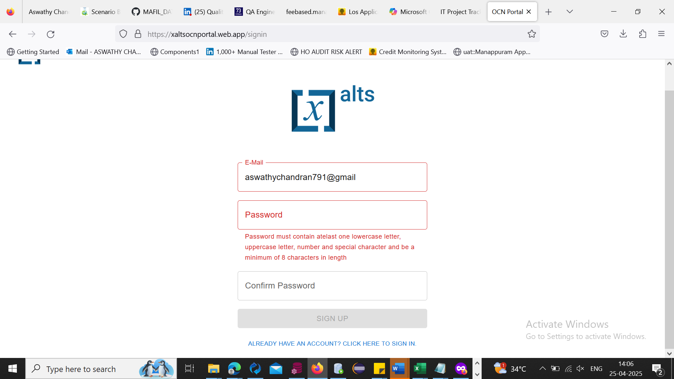

No error msg

But not enabled

INVALID PASSWORD

(less than 8 char)

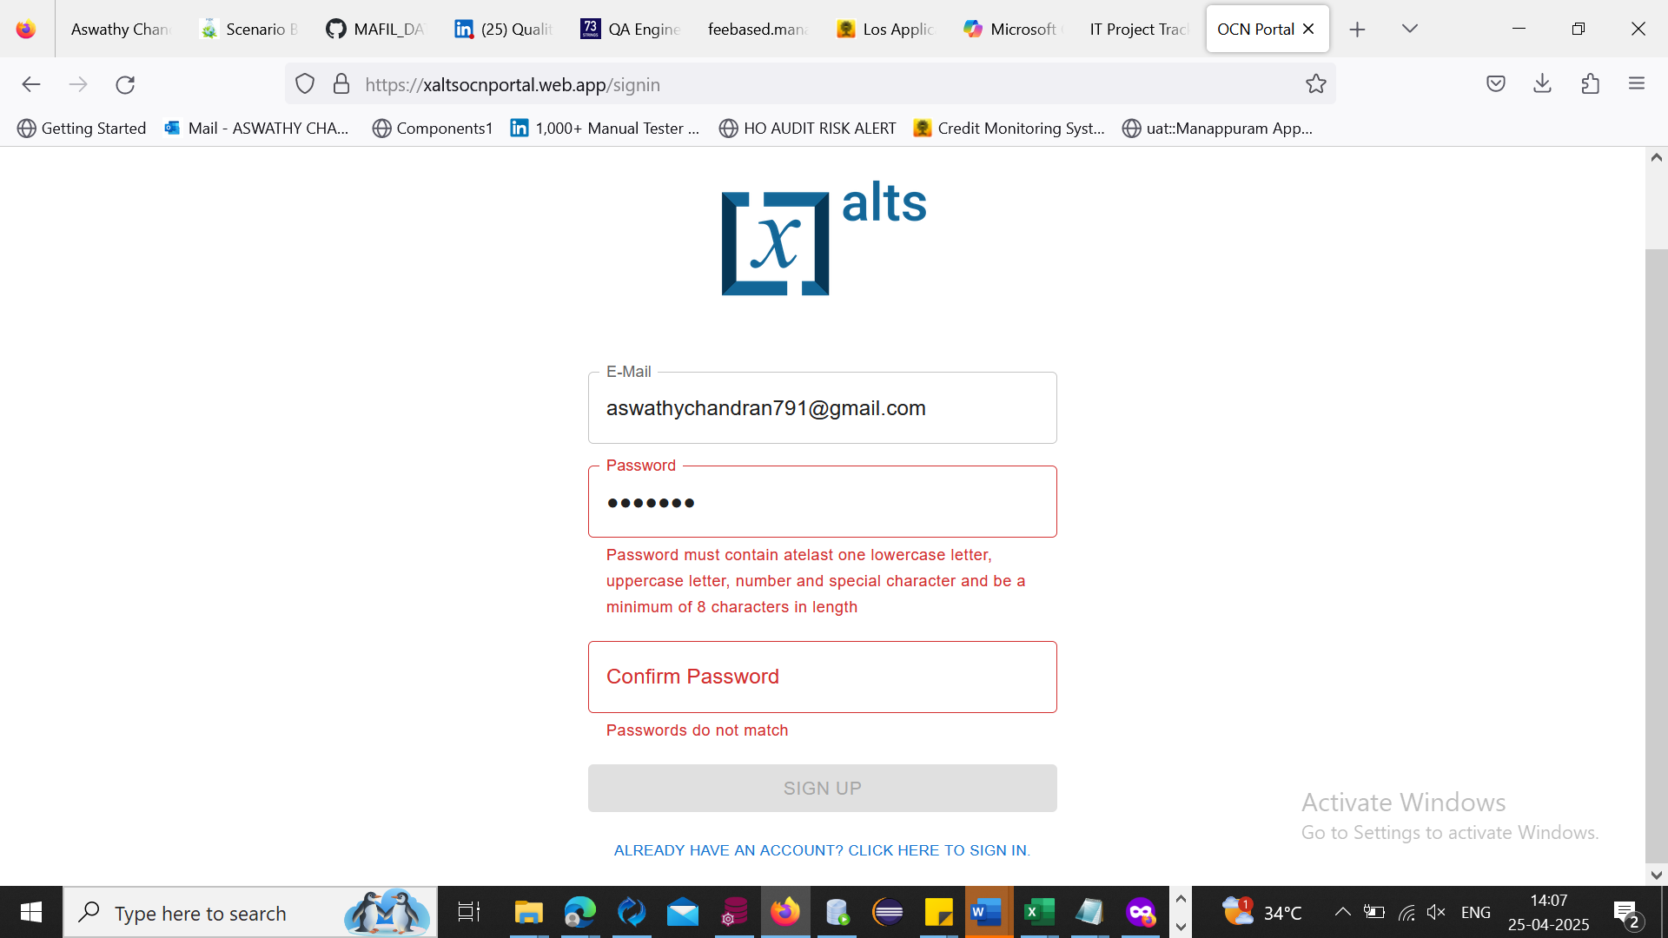

No error msg

Bt not enabled

There is no popup for atleast select 8 characters in length

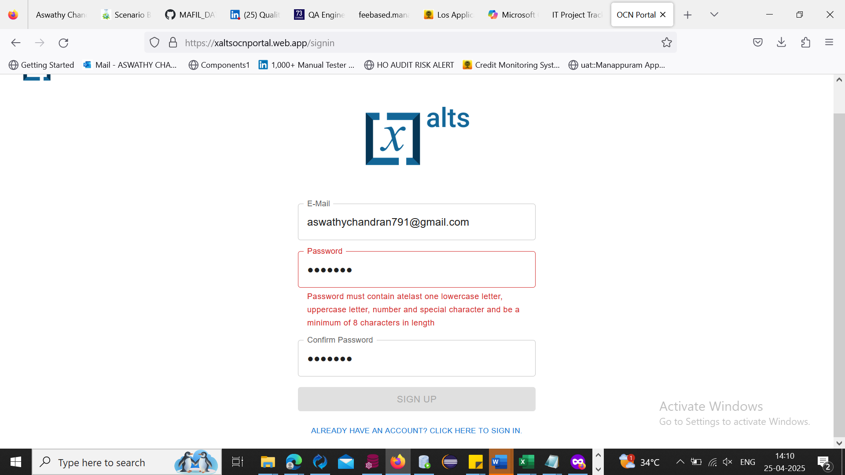

Confirm password also no popup message

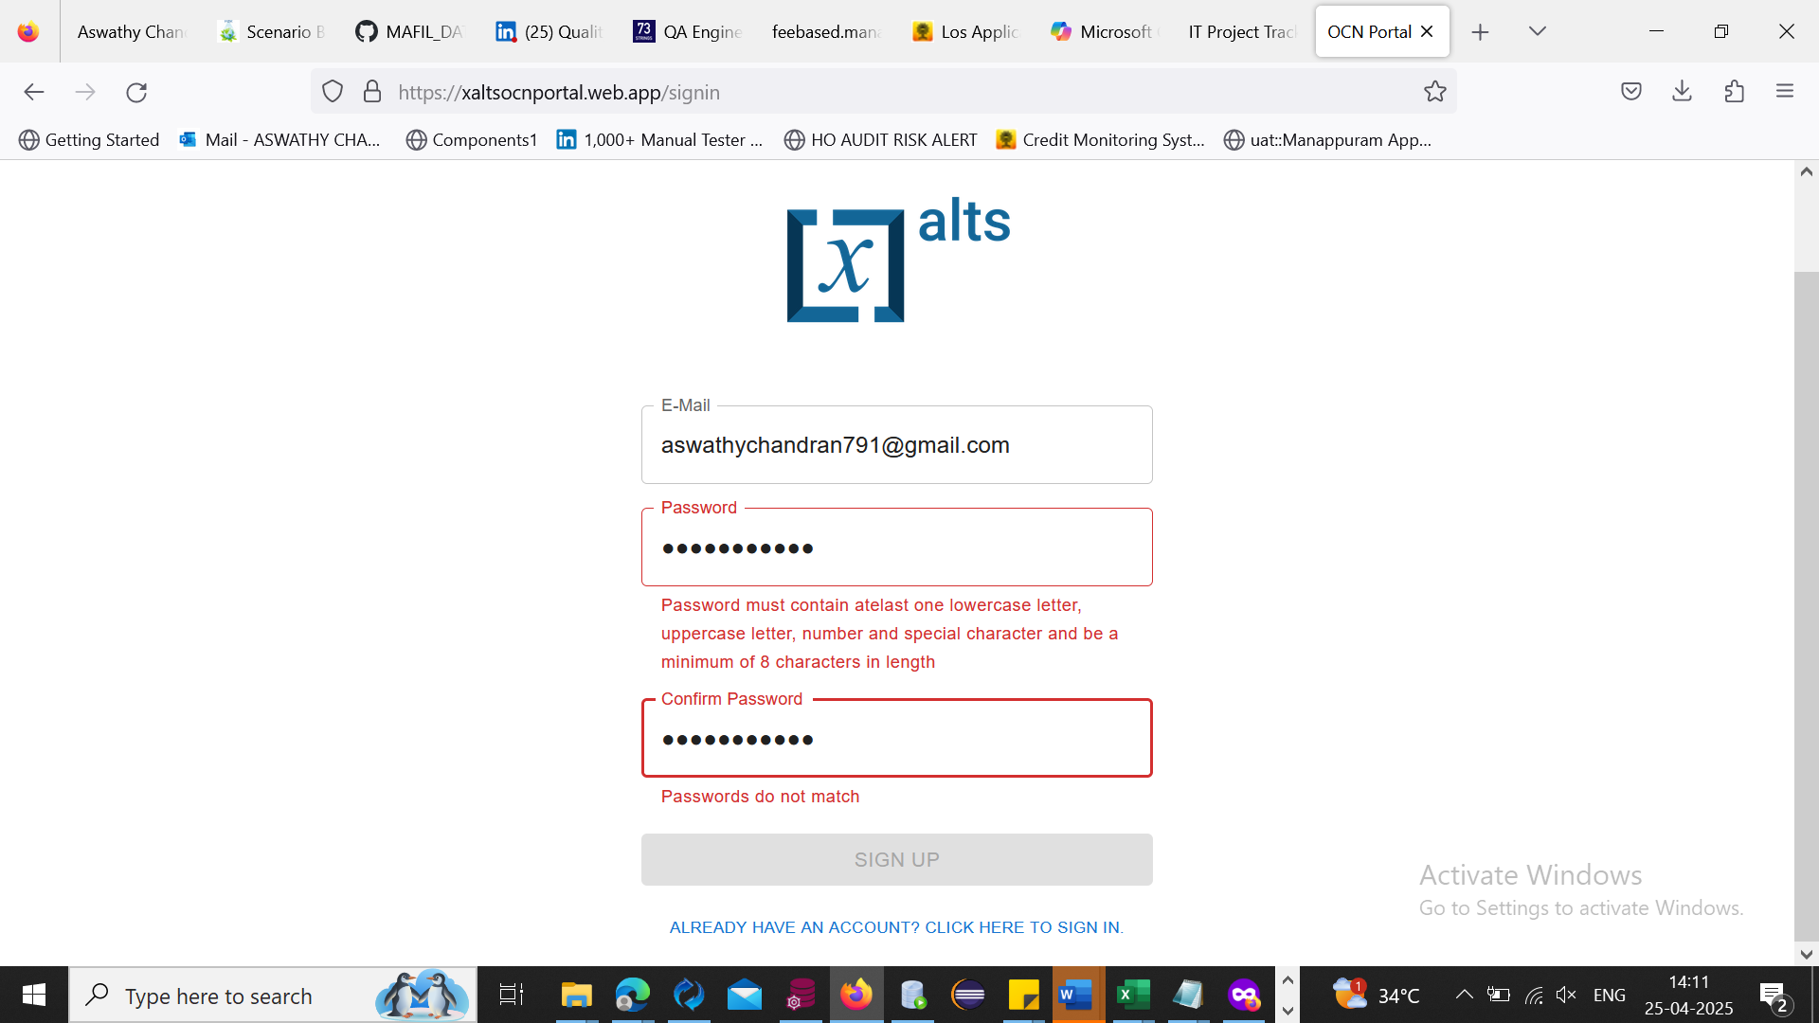

No special characters used

Bt no error popup message

VALID USER NAME AND PASSWORD

1. Sign Up: Create a new account with email id and password

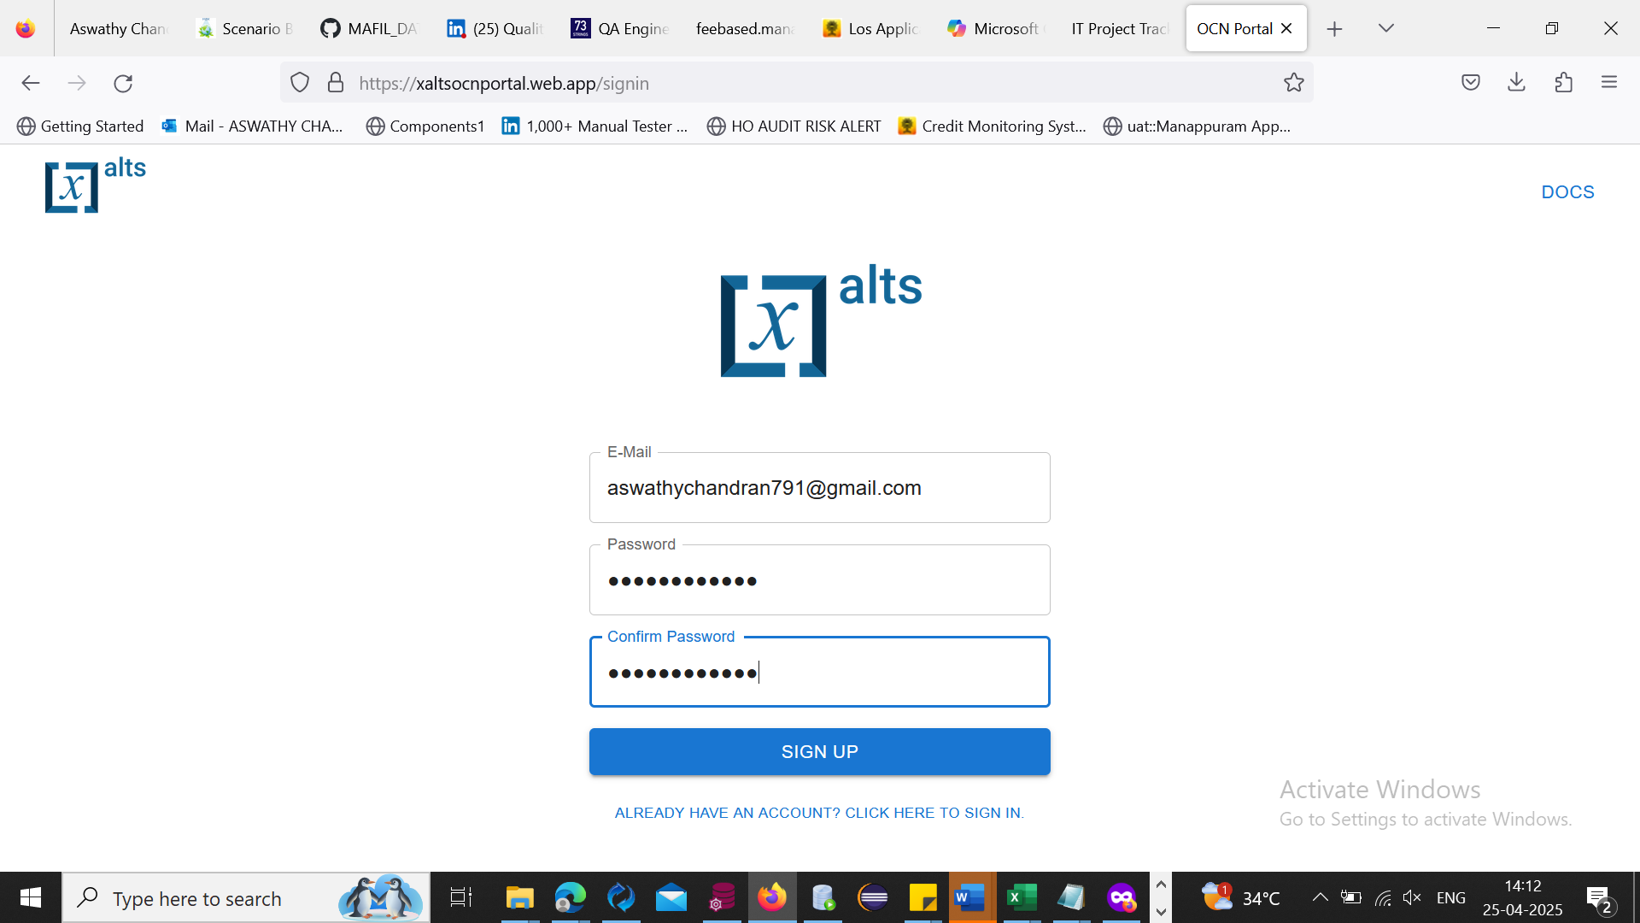

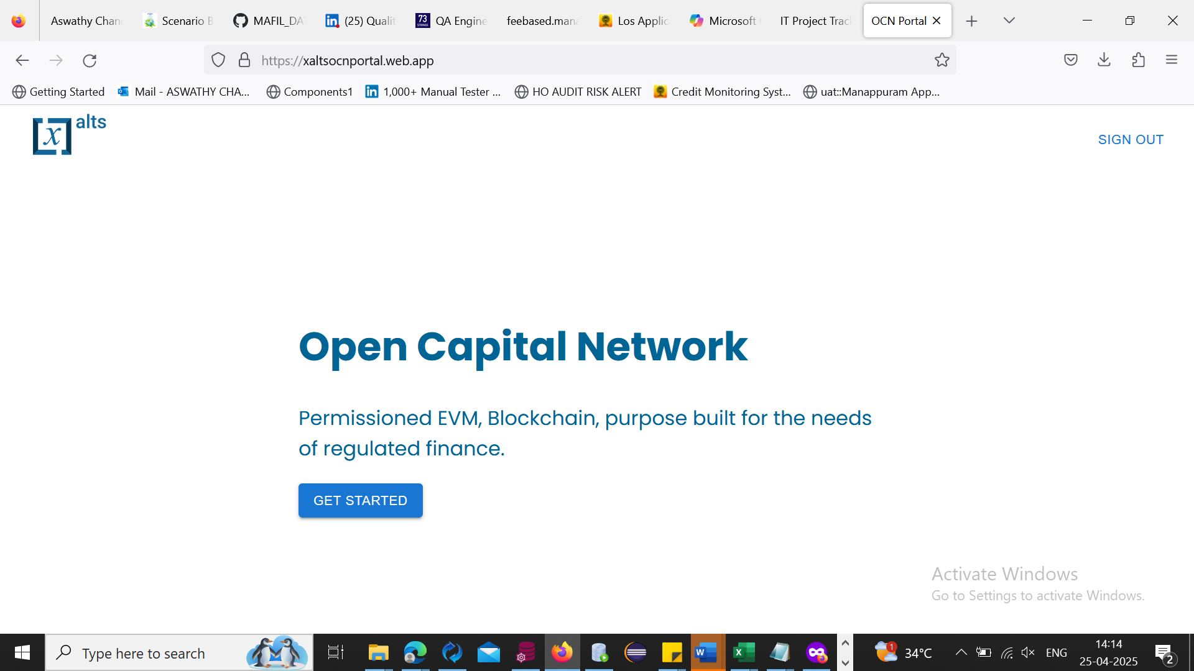

1. Sign In: Log in with an existing account

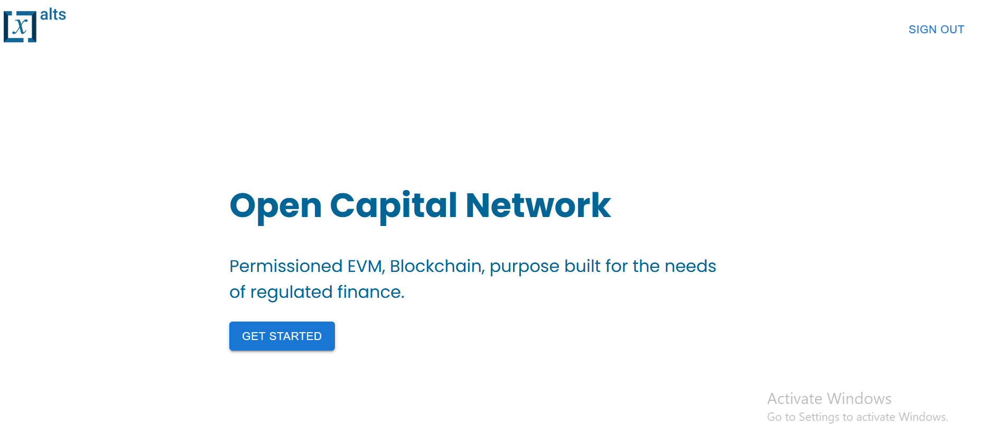

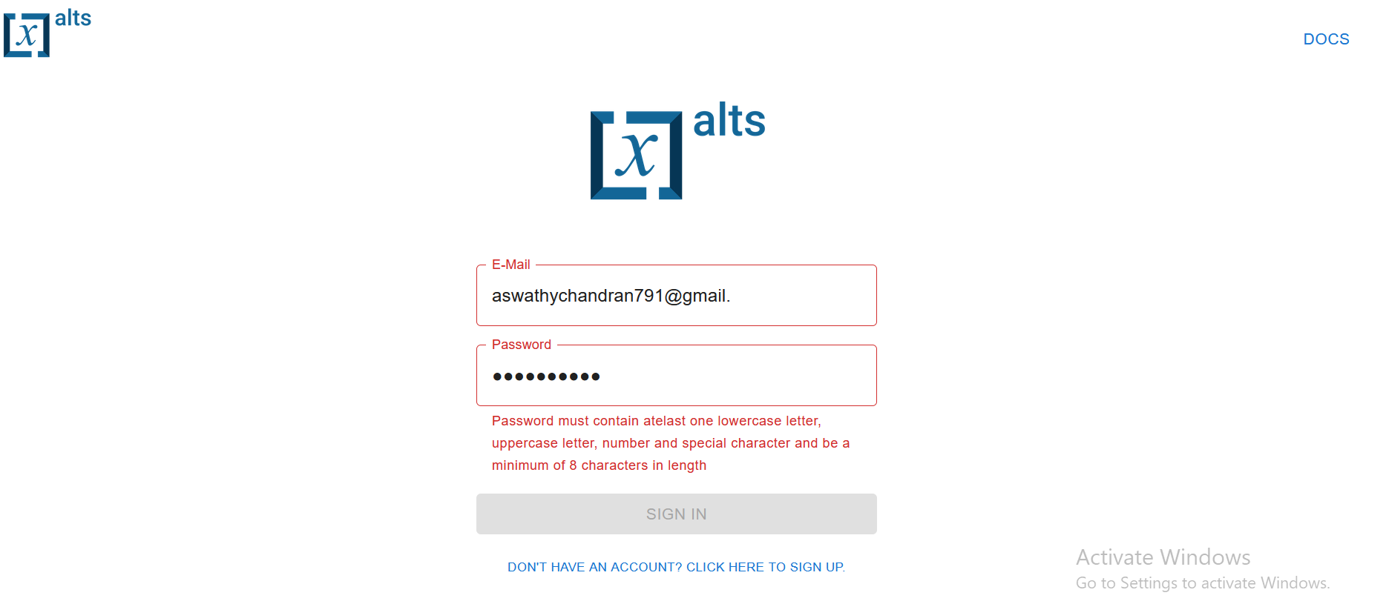

Invalid username and password

Valid username and password

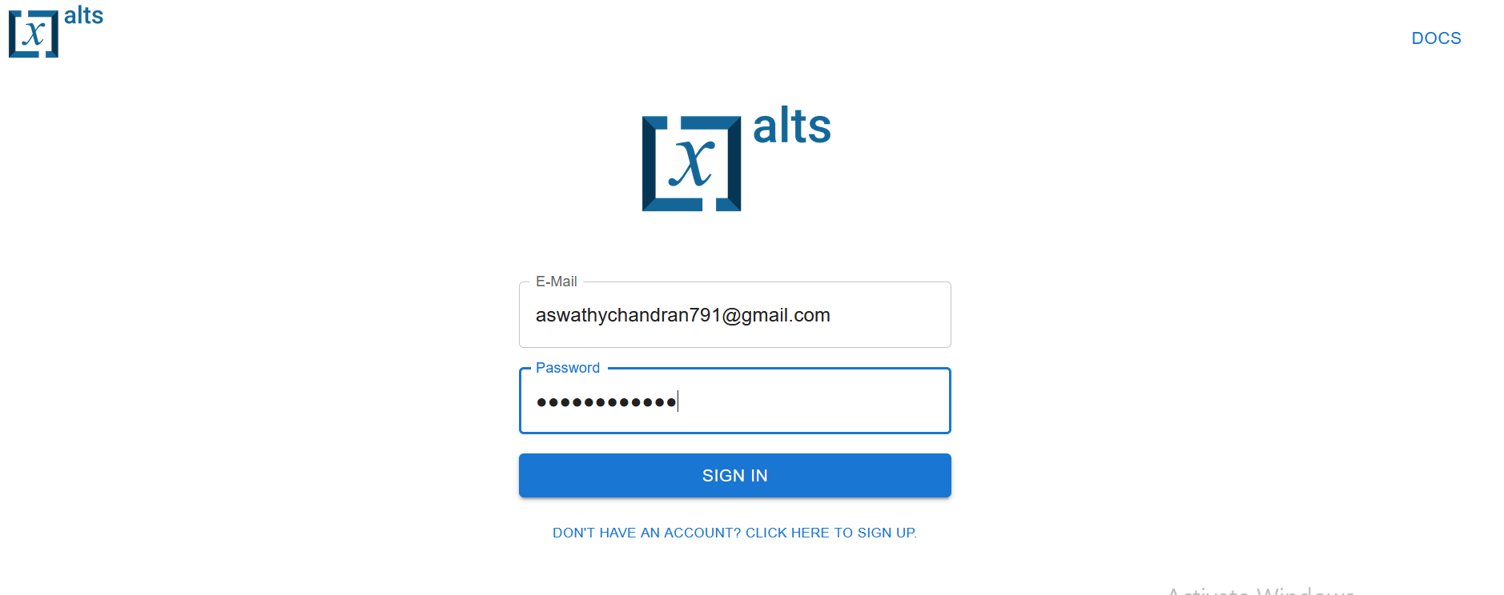

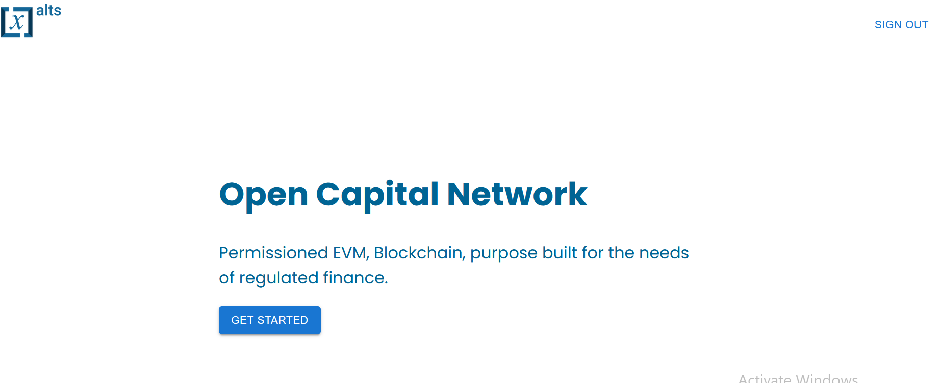

3. Submit Request To Onboard Nodes to Existing Blockchain

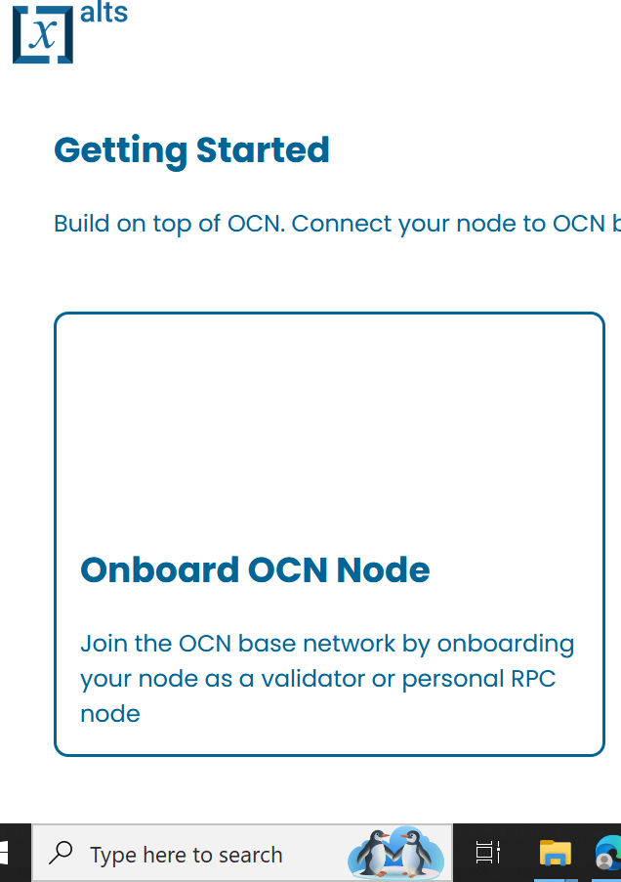

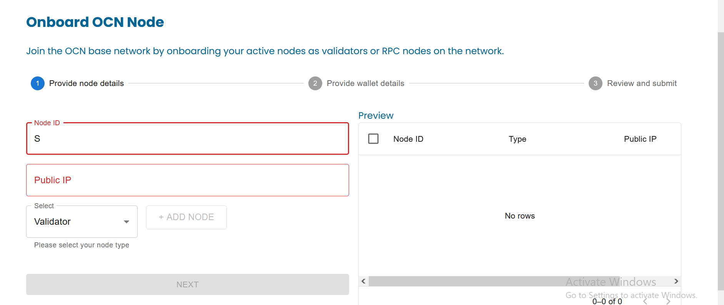

Bug reporting

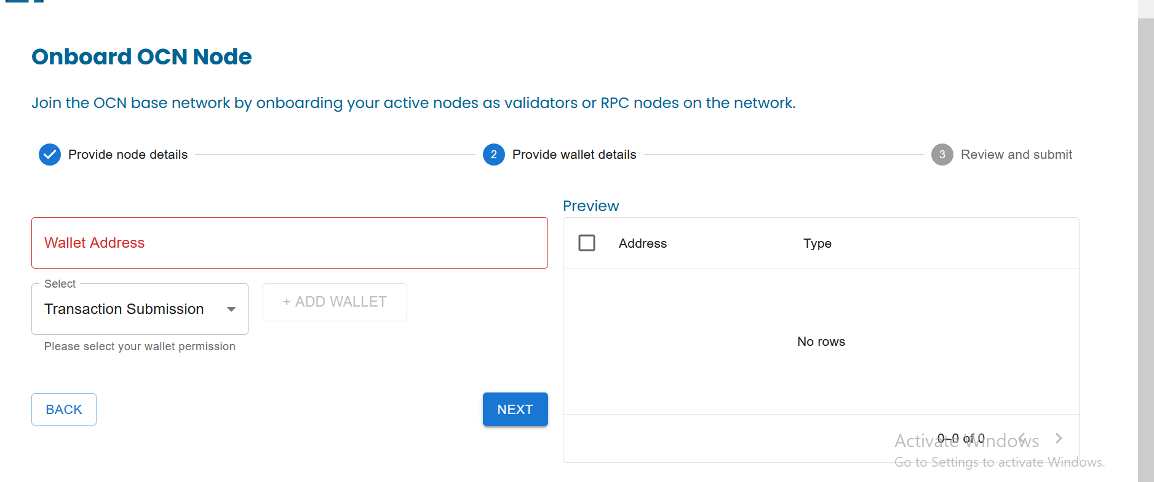

Invalid node id and ip address bt the module go through next step .(provide wallet details)

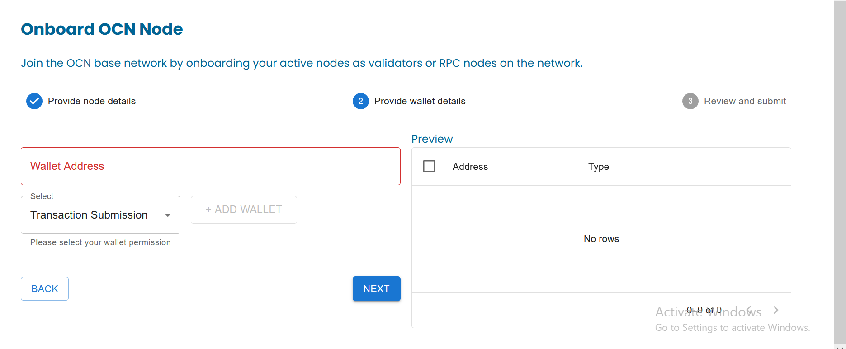

Without selecting any wallet details it goes through next stage (review and submit section

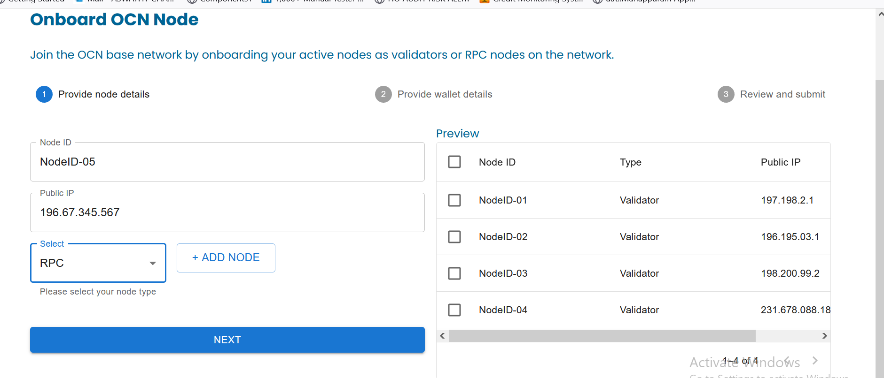

Bug reporting

X size is more than 255 bt it doesnot show any error msg

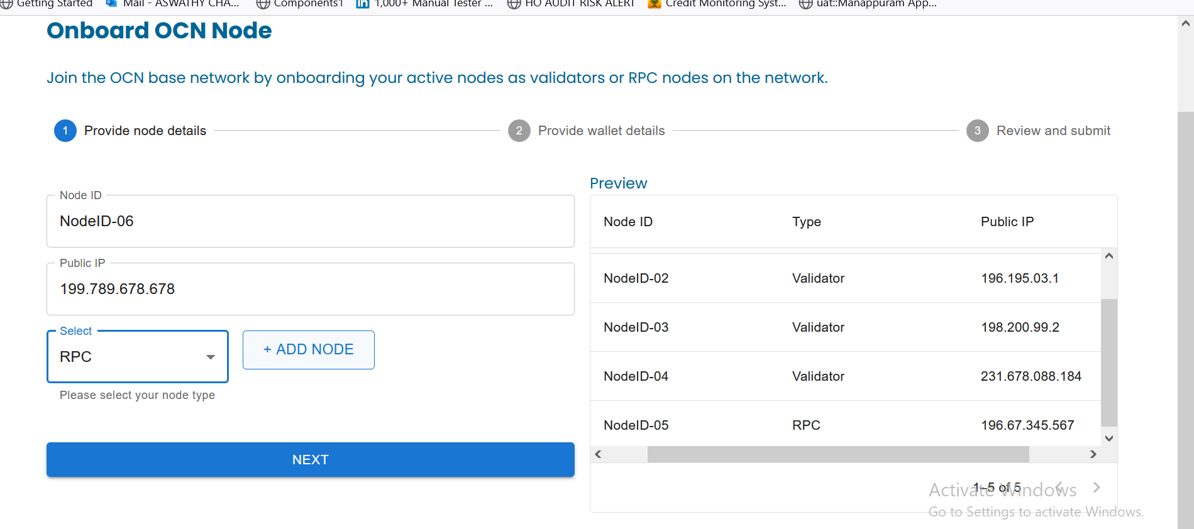

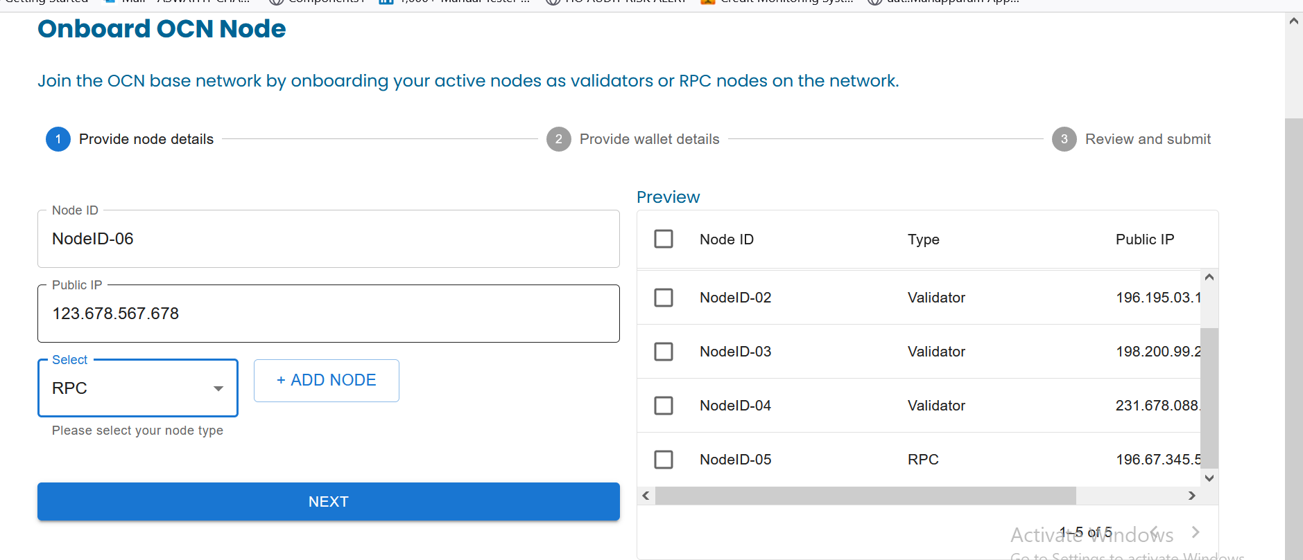

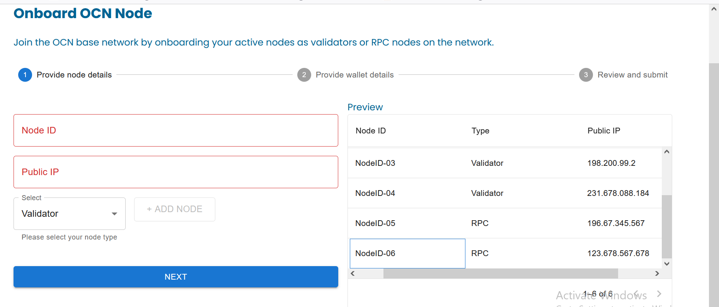

Removed node

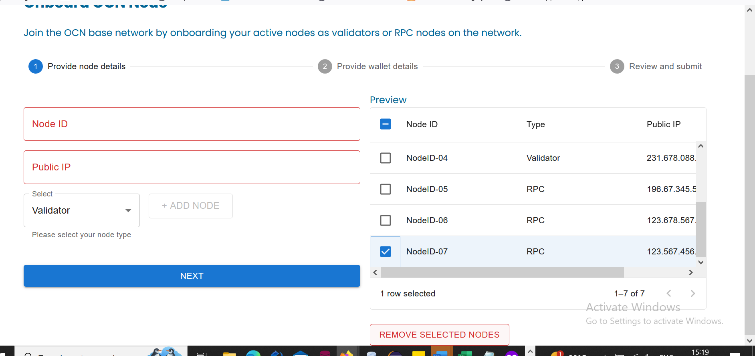

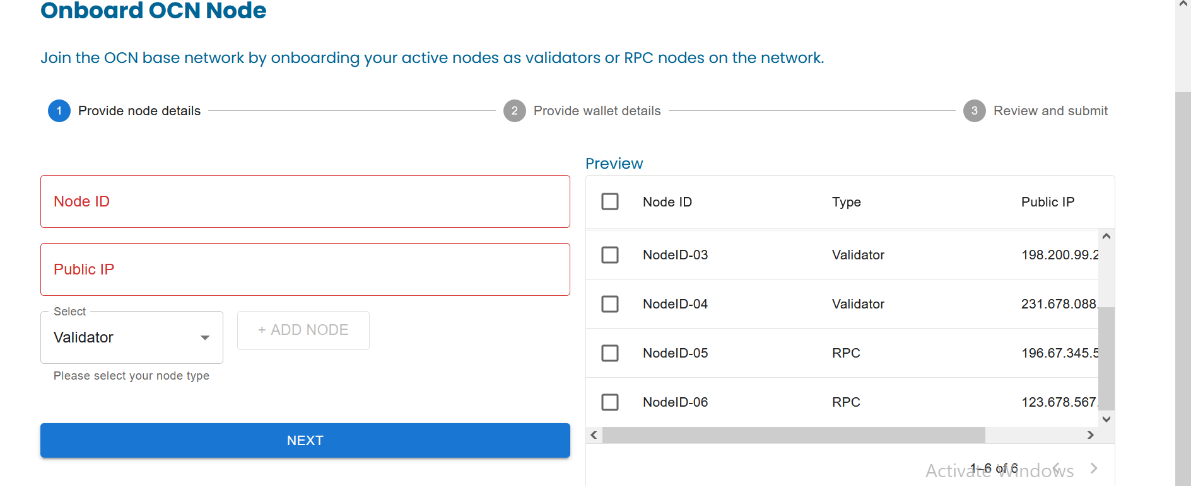

Wallet details

3. Submit Request To Onboard Nodes to Existing Blockchain

Submit button not working

No alert generated

If submit button not worked because of any miss match in ip address checksum value .. there must be a popup generated. But in here there is no popup showed.

NodeID-01

196.456.456.456

c

Launch OCN Child Network

There is something wrong in here but there is no error msg or popup message

Submit button is not working

I think the same issue I faced before

There is no error message or popup message

Sign out successfully

Automation code

